CSA1110- OBJECT ORIENTED ANALYSIS & DESIGN

EXP 3: EXAM REGISTRATION PORTAL

DIAGRAM 1: USE CASE DIAGRAM

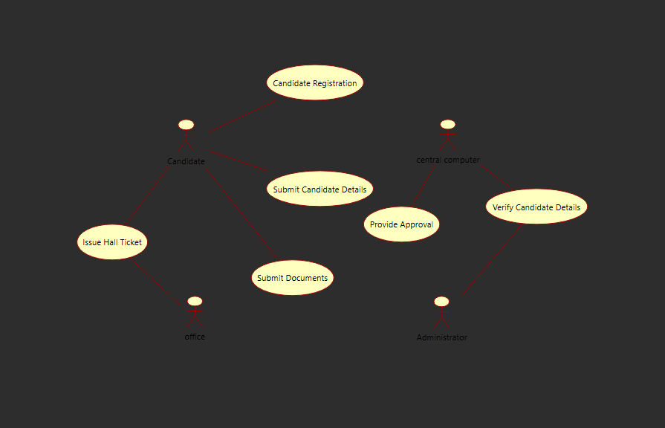

DIAGRAM 2 : CLASS DIAGRAM

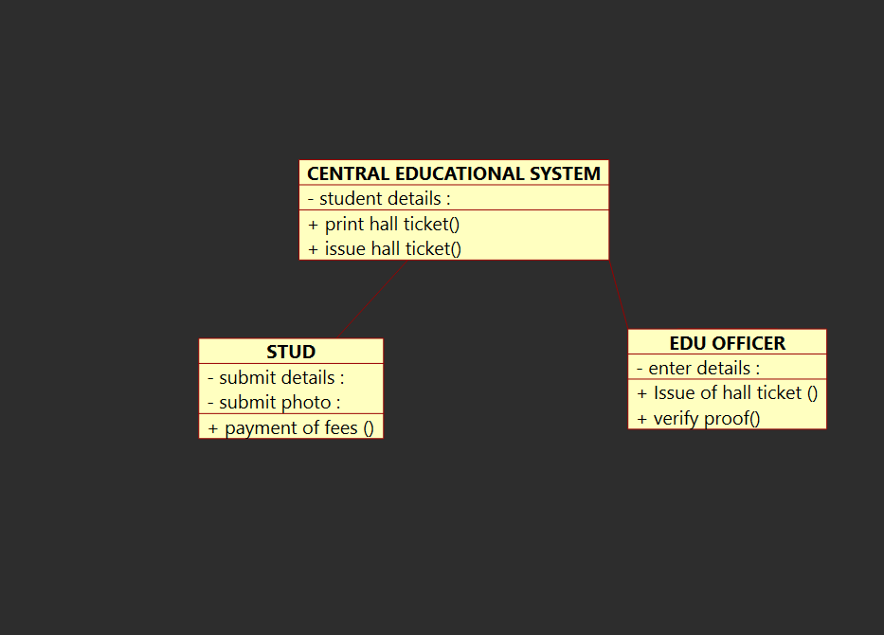

DIAGRAM 3 : SEQUENCE DIAGRAM
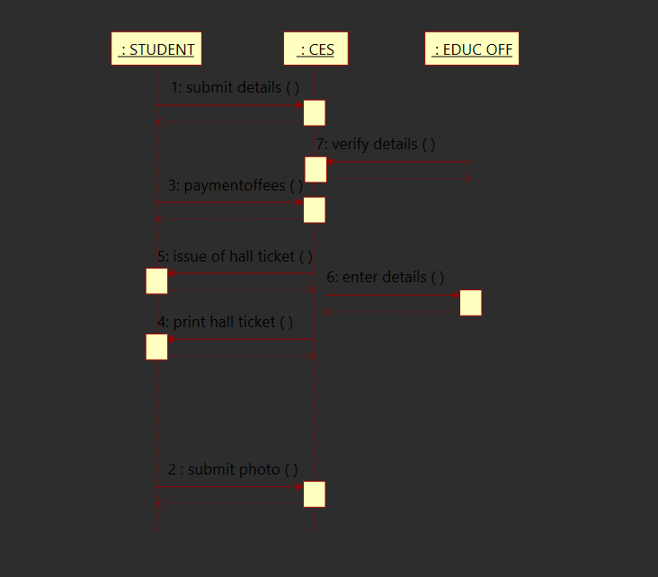

DIAGRAM 4 : COMMUNICATION DIAGRAM

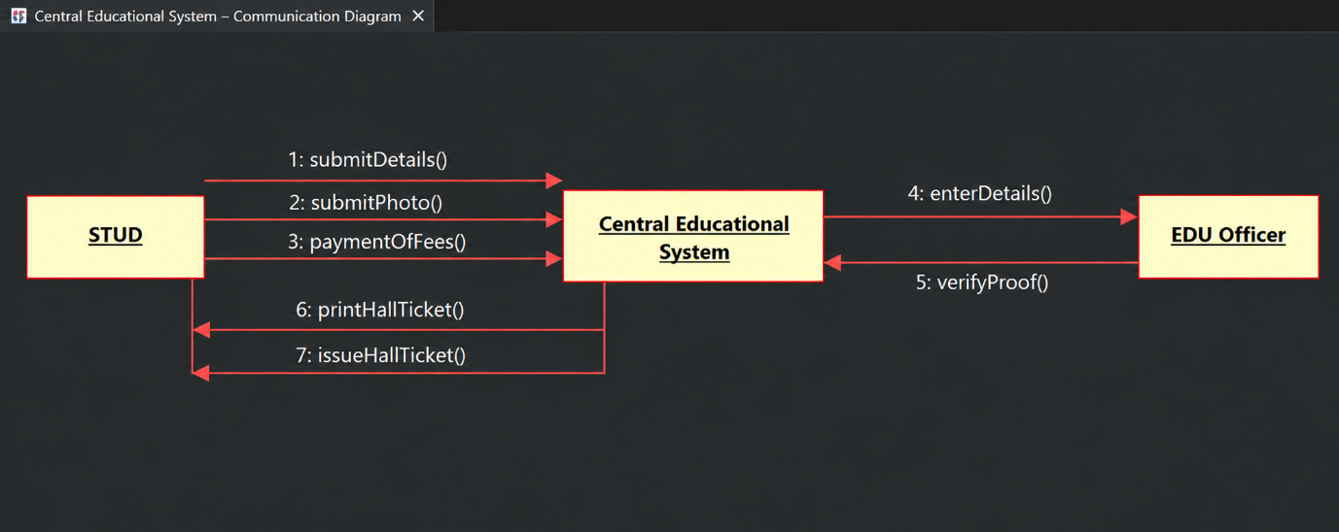

DIAGRAM 5: STATE DIAGRAM

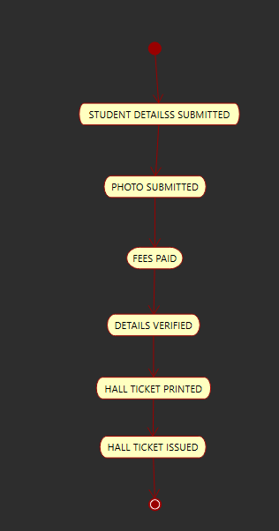

DIAGRAM 6 ACTIVITY DIAGRAM

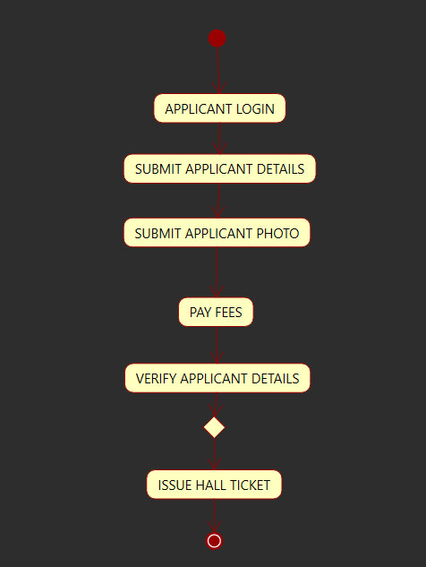

DIAGRAM 7 COMPONENT DIAGRAM

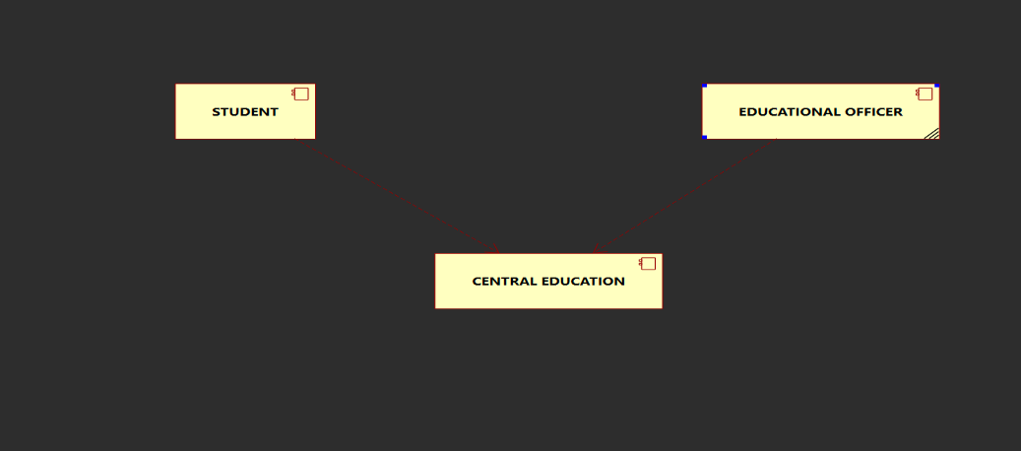

DIAGRAM 8 DEPLOYMENT DIAGRAM

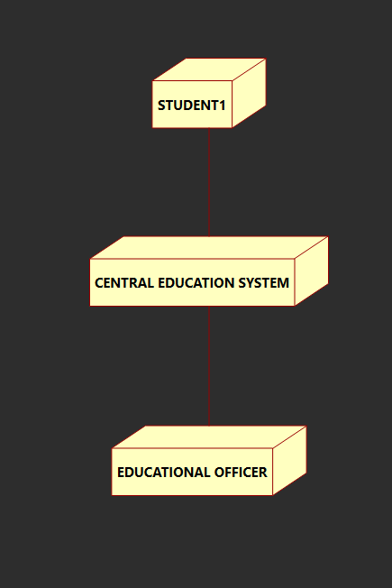
CODE

from CENTRAL_COMPUTER import *

class ADMIN:

"""
:version:
:author:
"""

""" ATTRIBUTES

STUDENT_DETAILS (private)

BOOK_LIST (private)

"""

def verify_student_id_(self):
"""

@return :
@author
"""
pass

def check_avalaibality_(self):
"""

@return :
@author
"""
pass

def issue_books_(self):
"""

@return :
@author
"""
pass

def order_new_books(self):
"""

@return :
@author
"""
pass

def maintain_student_details(self):
"""

@return :
@author
"""
pass

class BOOK:

"""
:version:
:author:
"""

""" ATTRIBUTES

book_id (private)

book_name (private)

avalaibality (private)

"""

def check_avalaibality(self):
"""

@return :
@author
"""
pass

def issue_book(self):
"""

@return :
@author
"""
pass

from BOOK import *

class CENTRAL_COMPUTER:

"""
:version:
:author:
"""

""" ATTRIBUTES

student_details (private)

"""

def verify_student_details(self):
"""

@return :
@author
"""
pass

def provide_approval(self):
"""

@return :
@author
"""
pass

from ADMIN import *

class STUDENT:

"""
:version:
:author:
"""

""" ATTRIBUTES

student_if (private)

student_details (private)

"""

def request_book(self):
"""

@return :
@author
"""
pass

def return_book(self):
"""

@return :
@author
"""
Pass

OUTPUT

